Clarification For: What does this have to do with the brain?

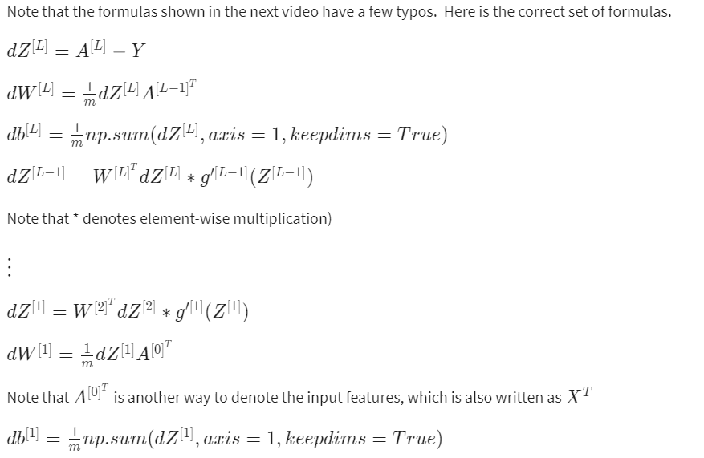

# References

### **W​eek 2:**

* [Implementing a Neural Network from Scratch in Python – An Introduction](http://www.wildml.com/2015/09/implementing-a-neural-network-from-scratch/) (Denny Britz, 2015)
* [Why normalize images by subtracting dataset's image mean, instead of the current image mean in deep learning?](https://stats.stackexchange.com/questions/211436/why-normalize-images-by-subtracting-datasets-image-mean-instead-of-the-current) (Stack Exchange)

### **W​eek 3:**

* [Demystifying Deep Convolutional Neural Networks](https://www.cs.ryerson.ca/~aharley/neural-networks/) (Adam Harley)
* [CS231n: Convolutional Neural Networks for Visual Recognition](https://cs231n.github.io/neural-networks-case-study/) (Stanford University)

### **W​eek 4:**

[Autoreload of modules in IPython](https://stackoverflow.com/questions/1907993/autoreload-of-modules-in-ipython) (Stack Overflow)